Nordstrom Inc.
Tatiana Rengifo
Southern New Hampshire University
7/19/20

Investment Project
Nordstrom Inc. is an American store that started in 1901 as a shoe store on Fourth and Pike in Seattle. With time the company diversified its products and started dealing with some other additional lines of products. The business began to deal with fragrances, cosmetics, accessories, jewelry, handbags, footwear as well as clothing (Nordstrom, 2020). The organization kept on expanding and started to open some other additional stores, for instance, it opened a store in Seattle’s University District. Since then the company has continued to expand to other parts of the world to enhance its global reach.
A Chinese market is an ideal place where Nordstrom Inc. needs to establish itself. The Chinese have appeared to like American brands. Therefore, by considering the attractiveness that the American brands have shown in the Chinese market, it can be asserted that there exists a market gap that needs to be filled. The American brand has always been premium-priced which means that the company will end up making profits within the Chinese market.
One of the financial market metrics that seem to be in play, in this case, is that of time. Regardless of the industry within which a firm operates, every firm operates both internal as well as external processes. Therefore, it is essential to measure the time taken to begin and to end. This is essential since it has given the managers a chance to establish a solid baseline data which could be used to make decisions about the allocation of resources and human capital. It is through the baseline data that has been collected that enables the management of the company to identify prime areas for cycle time reduction as well as setting data-driven goals to enhance efficiency in the future.

Costs
Every business measures costs that are expected to be incurred. In most cases, all businesses talk about costs in terms of the budgeting process. The most important sections that should be looked at closely are the administrative and knowledge-based functions such as intelligence collection as well as analysis. The managers need to point out the regions where the costs are indeed occurring and then break them into various categories such as errors, resources, time as well as manpower (Calhoun, 2020). Decision-making metrics should also be showing when the costs are either rising or falling.
Return on Investment
Since this will be a new outlet, there is a need to consider the return on investment. The payoffs and the benefits must be considered for any given new investment. It is the only thing that can give a business person a chance to calculate the return on that given investment. Private companies are usually meant to earn profit from any given investment (Calhoun, 2020). Therefore, to defend robustly an investment or rather a proposed budget to secure future funding for the business, the return on investment must be several times over and above the project’s costs.
- Investment Project: Resources
The company will just lease an already build shop. However, the shop will need to be of the required size and it must be strategically resources. The other resource that will be needed is that of human labor or human capital. Since the company will be establishing a shop in a foreign market (Chinese Market), the front shop attenders will be locals. However, the management will comprise of only Americans. The company has to establish its presence in foreign countries to keep its profit growing (Barbra, 2010). Such an arrangement will help in ensuring the smooth operation of the company in the Chinese market. The other resource that will be required is that of technology (Calhoun, 2020). The shop attendees will be given tablets from which they can be feeding the response of the customers so that the company can know the trend in fashion as well as ensuring products are tailored to meet the customers’ specifications. The company will also obtain trade certificates from the Chinese trade union to be allowed to carry out trade. Besides, the company will also apply to have its intellectual property rights acknowledged and protected in China. There are government legislation and administrative regulations that are meant to protect the areas of trademark, patent as well as copyright.
The company will also require funding for the new venture into the Chinese government. Since the company’s financial resources are inadequate, the business will have to go for a loan from a financial institution within the United States of America. The company’s management will approach the International Finance Corporation (IFC) to request funding of $1 million.
- Investment Project: Time Frame
The time required to set up the shop and have business running will be 12 months. This will be sufficient time to allow for ensuring all the required arrangements are made. The time frame of the business is as follows:
12 Months Before Start-Up
This period will be plenty to enable researching the business. It is during this time that the managers will be able to turn the idea into an operational business. The managers will schedule meetings with some other business professionals such as attorneys, bankers as well as accountants. The managers will enquire regarding licensing and permit requirements, tax-implications as well as costs to be incurred by the start-up (Kurowski, L., & Sussman, 2011). They will also visit the proposed location and visit some other prospective properties.
9 Months from Start-Up
Nine-months before starting the shop in China, the management team tasked with the processing of the required documents, will start applying for licenses and permits. Normally, there are city and state agencies that are tasked with issuing licenses as well as permits to foreign investors. In this case, the business will require a general license which can be obtained from the city of operation. The city where the company will be looking forward to setting up its shop is in Shanghai.
Six-months from Start-Up
Six months before the business starts to operate, the application of permits and licenses should be in progress. In this case, the business will be operating as a corporation. Therefore, within this period, the managers will apply for articles of organization and pay for the necessary filing fees (Kurowski, et al., 2011). It is within this period, that the marketing team should start executing its marketing plan within the Chinese market. The business will also apply for its listing in the local phone directory. Opening of bank account and application for loans as well as obtaining employer identification number with the IRS will be carried out within this period.
Three months from Start-Up
Within the last three months towards the start of the operation of the business, all the necessary legal necessities should have been taken care of. Now it is time to purchase the required equipment and arranging for their delivery. This is also the period within which the managers will apply for a merchant account to enable credit card payments. The human resources manager will also write job descriptions and have the job posting in place to attract qualified employees (Kurowski, et al., 2011). A week or two to opening doors for customers, the marketing team will ensure announcements are published in local business publications as well as in the newspaper.
Anticipated Economic Life
The anticipated economic life of this company will be approximately 50 years. The company will have to be flexible and be able to adapt to changes. Changing with the times is important for a business that wants to survive for a long time. However, the business might not function as earlier expected by the investors. One of the financial factor to consider before ending a business is that of return on the investment. If the business continues to make losses after having tried a variety of approaches to stabilize it, then it will be time to call it quits (Kurowski, et al., 2011). The other thing that an investor should consider is that of uncertainty in the market of operation. At times, a business might be successful today but when predicting about its future, it turns out to indicate market uncertainty.
When the time for exiting the market comes, Nordstrom Inc. China will have to be merged or acquired by Chinese general supplier companies such as Alibaba. Alibaba has indicated that it can do well in the marketing of products produced by other manufacturers across the globe. Therefore, the formed company will bring economies of scale and enable its operation which will result in being profitable.

- Justification: Why now
The Chinese shoe, clothing as well as jewelry market appears to be promising. The Chinese market of the listed products appears to be growing progressively. For instance, the Chinese footwear market is expected to reach $70 billion by 2021 (Chinese Consumers and the Fashion Market, 2019). Therefore, this is a factor that should act as a bait for Nordstrom Inc. to establish shops in Shanghai, China so that it can continue making a profit. Another factor is that the Chinese appear to be associated with American brands. Therefore, the company will be in a position to make sales that will at the end of the trading period make the company earn the profit. The other factor to consider in this case is that of the trend in foreign investment in China. Between January and April, direct foreign investment fell. This trend could be sited to the uncertainties that have been brought about by the spread of the Covid-19 pandemic. However, this year as June kicked in FDI increased by 7.1% to CNY 117 billion (Chinese Consumers and the Fashion Market, 2019). This is a positive indicator of a promising market soon.
Fig.1.0
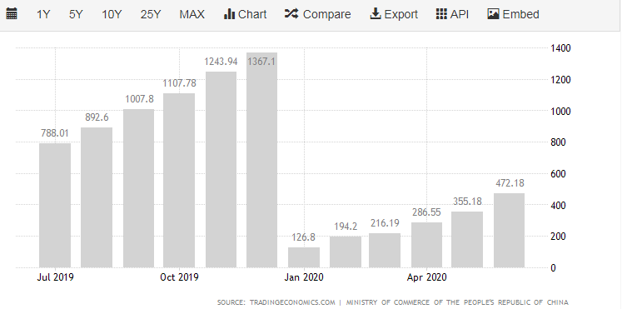

Link:
https://tradingeconomics.com/china/foreign-direct-investment#:~:text=Foreign%20Direct%20Investment%20in%20China%20is%20expected%20to%20be%20550.00,macro%20models%20and%20analysts%20expectations.&text=In%20the%20long%2Dterm%2C%20the,according%20to%20our%20econometric%20models.
- Justification: Strategic Fit; Microeconomic
Microeconomic factors influence the operation of a business, specifically global expansion. Thus, in this case, the most important factors to consider are the price elasticity of products, level of competition within the market as well as the state of the economy (Besanko & Braeutigam, 2014). The state of the economy determines how much the consumers will spend and thus responsible for setting the consumer’s spending trends. If there happens to be a downfall in economic growth in China’s economy, the spending of the consumers will fall. On the other hand, the improvement of China’s economic state will lead to the escalation of consumer spending. For Nordstrom Inc. to achieve sustainable growth within the Chinese market, the company has to manage its risks and threats effectively as well as coordinating appropriate productivity across all departments of the organization. As illustrated by Fig.1.1, it appears that the company’s annual revenue has been growing over the years. The same trend is possible to be replicated in the Chinese markets after the company establishes its presence. The company has to ensure its customer’s experience as well as security to guarantee an upper hand when it comes to competition within the industry of operation (Besanko, et al., 2014). For Nordstrom to succeed in international markets, the company has to keep both its global e-commerce price as well as its divider costs relatively close.
Fig. 1.1
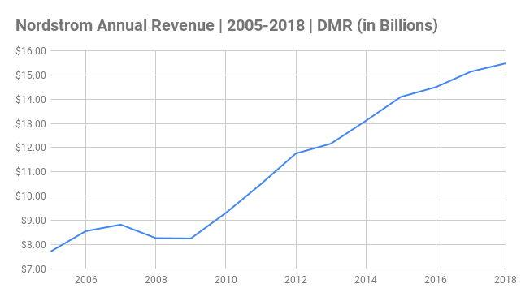
Link: https://expandedramblings.com/wp-content/uploads/2018/09/Nordstrom-Annual-Revenue-_-2005-2018-_-DMR-in-Billions.png
Fig. 1.2
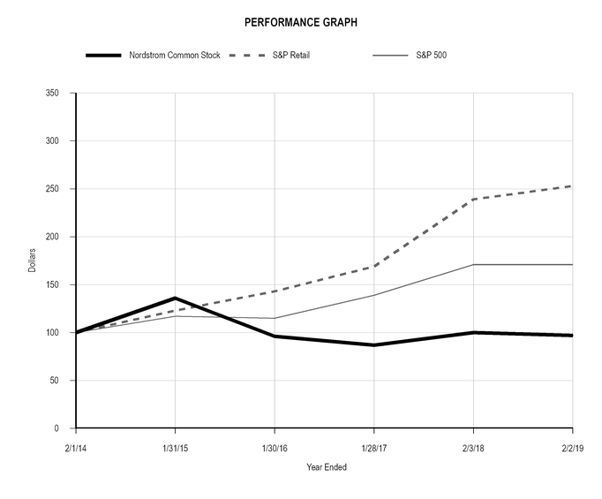
Link: https://www.google.com/url?sa=i&url=https%3A%2F%2Fwww.sec.gov%2FArchives%2Fedgar%2Fdata%2F72333%2F000007233319000060%2Fjwn-222019x10k.htm&psig=AOvVaw1yKbHEFTBtBul4ZVmAUetn&ust=1594987094569000&source=images&cd=vfe&ved=0CAIQjRxqFwoTCNiBwJnc0eoCFQAAAAAdAAAAABAD
- Justification: Strategic Fit; Comparative Advantage
By establishing the shop in Shanghai city, the company will enhance its core competence as well as its comparative advantages. The company has in place personal stylists who are at the disposal of the customers who might log on to their e-commerce or website as well as in brick and mortar shops. The personal stylists will give the customers the fashion advice they might require (Berry, 2008). The company will also ensure onsite alterations as well as tailoring. There will be standby tailors who will be ready to perform the alterations required by a customer at Nordstrom local. This will be made possible by having established a mortar and brick store in china. On the other, the company will in return have enhanced customer experience. There will also be a style board where the company’s salesperson can create digital boards that are filled with personalized fashion recommendations, for instance, for summer vacations, wedding as well as some other events (Berry, 2008). The customers will be able to view online and purchase at the comfort of their homes or offices. This will give the company property intellectual advantage.

References
Barbara, T. (2010). All Abroad: Retailers Head Overseas to Boost Growth. CNBC Markets, https://www.cnbc.com/2010/06/03/all-abroad-retailers-head-overseas-to-boost-growth.html.
Berry, T. (2008). The Plan-As-You-Go Business Plan. New York: Entrepreneur Press.
Besanko, D., & Braeutigam, R. R. (2014). Microeconomics.
Calhoun, G. (2020). Price and Value: A Guide to Equity Market Valuation Metrics.
CHINESE CONSUMERS AND THE FASHION MARKET. (2019). S.l.: SPRINGER.
Kurowski, L., & Sussman, D. (2011). Investment project design: A guide to financial and economic analysis with constraints. Hoboken, N.J: John Wiley & Sons.
Nordstrom. (2020, July 9). Nordstrom. Retrieved from https://www.nordstrom.com/browse/about/company-history

